Team,

I want to share a reminder of what we’re capable of when we operate with intention, discipline, and pride in our craft. I hope it prompts all of us to take a hard look at how we’re approaching BD today. We’re in a market now where tons of tools help with outreach, so hiring managers are getting more specs than EVER before. Generic outreach gets ignored. Precision is the only thing that cuts through.

Mastering BD isn’t just how we win clients – it’s how each of you accelerates your own career, build a book of business, and becomes indispensable in this market. This email is all about understanding what has worked, what hasn’t, and adjusting what we need to win in the current market.

Historical Trends
2018 is proof of what happens when a team commits to targeted, thoughtful, high-quality BD. Back then, we didn’t have SourceWhale. We didn’t have InMails for BD. We didn’t have AI. What we did have was focus, consistency, and a willingness to out-research and out-execute everyone else in the market.

In 2018, every spec we sent was tied to a specific target job we identified through company career pages, LinkedIn, MassBio/BioSpace, or leads from candidates. We mapped out who the hiring managers were, and sent them personalized emails with targeted specs. When emails weren’t listed, we tested formats manually until we got a delivery receipt. It was gritty, and it opened doors that built the foundation of this team. We reached out to 818 companies, across 4,850 total specs. That’s a ratio of 6 specs per company annually.

I believe this style of outreach/level of personalization is how most of us want to do BD today. There is a TON of value with this approach – I ask each of you: Are you achieving 25 targeted BD messages each week? Or is it closer to 3 to 5, and then supplemented with some more generic higher volume at EOM? I’ve found that in order to see success with this method, ~100 very personalized specs per month results in 1 new client. So, it needs to be a daily targeted activity, mapping new clients, jobs and speccing to the most relevant stakeholders at them consistently, plus solid follow ups and voicemails/cold calls.

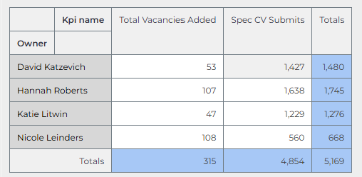

When 2020 hit, arguably one of the toughest markets we’ve ever seen… we adapted. We specced to posted jobs and were told the company was on a hiring freeze. Literally all our clients paused hiring outside Kiniksa, who continued with their commercial build. So, we pivoted. We built MPC campaigns to companies with no active openings. We asked about hiring timelines for Head of [X] roles, that were yet to be posted but that we knew were gaps in their leadership teams after market mapping out the entire org. We mapped emerging companies weekly. We still see the ripple effects today. My Sirius search came directly from one of Taylor’s Head of CMC campaigns. The CSO remembered her outreach YEARS later. That’s the power of targeted BD.

Check out the data but some team members reached nearly 5,000 targeted specs a year – they were Associates less than a year into recruiting. They followed a process that works, and it helped them win, even in a tough market. This resulted in ~30,000 specs to 1,800 companies (an average of 16 decision-makers per company). No jobs posted = higher volume and follow ups over the course of the year with fresh specs testing out the need for other roles/functions than previously specced to.

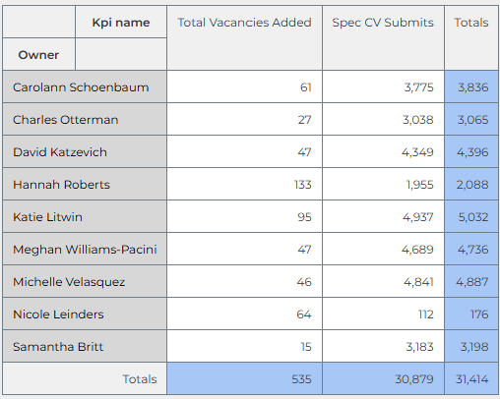

Where We Are Now
In the last 12 months, R&D has targeted 1,480 unique companies – which shows the strength of some of your market research. But the ratios tell a different story. Our style of outreach is more similar to the 2020 activity; we are running MPC campaigns for a lot of companies/hiring managers that don’t have a specific job posted. But we’re only averaging 6 contacts per company, compared to 16 in 2020. And too much outreach is happening in the final days of the month, going to gmail addresses or via InMail, without the research that makes outreach meaningful. Our lack of vacancy generation is likely a targeting problem.
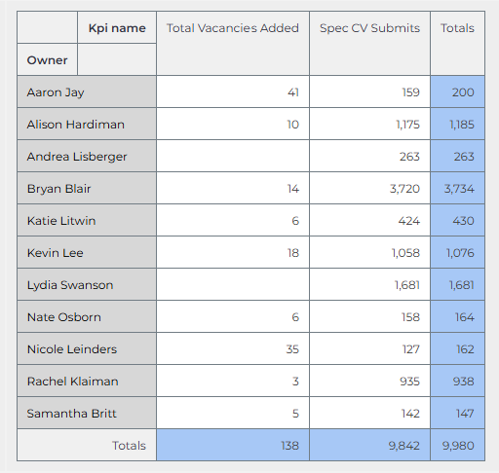

The Takeaway
This isn’t about doing more. It’s about doing the right things consistently. Targeted outreach to the right decision-makers, backed by real research creates opportunities is how we win. It’s how we differentiate, build credibility, and open clients who remember us months later.

I’m not asking anyone to do something new – I’m asking you to reflect on how much BD consumes your current workflows. A great BD week is one where you’ve mapped new companies that are (likely) hiring, identified the correct hiring managers, and sent targeted outreach. All this followed up with calls that reinforce your credibility and that you’re a real person, invested in working with them. Ask yourself:
- Am I sending targeted BD daily, or batching it at the end of the month? Ie - mapping new companies every week? Sending 25 targeted specs each week, across 5-10 specific companies?
- Am I identifying the actual hiring manager, mapped through linkedin and cross-referenced with zoominfo? Or messaging TA/HR hoping will advocate for me?
- Am I following up with calls and voicemails, or assuming email is enough?

We have the best tools. We have the best talent. We have the proof from prior years of what works. Now we need the discipline to build targeted BD at volume into our everyday workflows. If we get this right, we become the team that clients think of first. We’re proven market experts. We become the team that uncovers roles before they’re posted, that builds relationships before competitors even know the company exists. That’s the level we’re aiming for.

For the next 30 days, I challenge each of you to commit to consistent, targeted BD: daily mapping, daily outreach, daily follow-ups. If we do this together, the results will speak for themselves. I’m committed to helping each of you build these habits; through market mapping sessions, real-time feedback, and helping you stay accountable each week. More to come as we prep our Planning For Success for the next fiscal year!

